March 22, 2017
Dear Families,

On Thursday, April 13, 2017 grade four classes will be going on a field trip to the National Music Centre, Studio Bell. We will leave the school at 8:50 am and return in time for regular dismissal at the end of the day. We will be using Southland Transportation to reach our destination. The cost for this field trip was included within the one time payment of field trips for the year. If you haven’t already done so, please remember to pay your fee online at My CBE Account at https://webapps.cbe.ab.ca/MyAccount/Account/LogOn?ReturnUrl=%2fMyAccount%2

The curriculum connections for this field trip are: Grade Four Social Studies: The Stories, Histories and People of Alberta; Language Arts: Writing combinations of words to convey meaning and Music: Appreciation of a Variety of Music. During this educational experience students will have the opportunity to explore the exhibits on the 2nd and 3rd floors, attend a Kimball Organ performance and take part in the Words to Song workshop delivered by the NMC staff.

Students will need to bring a lunch, snack, water bottle and indoor shoes in their backpack. Any needed medications, epi-pens, inhalers also need to accompany your child. In addition, students and volunteers are encouraged to dress for the weather, as we will be going outside to access our charter bus.

We are looking for 5-6 volunteers for each class. If you are interested in volunteering for the day and have current CBE volunteer clearance, please contact your child’s teacher by Friday, April 7th. Thank you for reading this letter and helping to prepare your child for a fantastic day of learning at The National Music Centre, Studio Bell on Thursday, April 13, 2017.

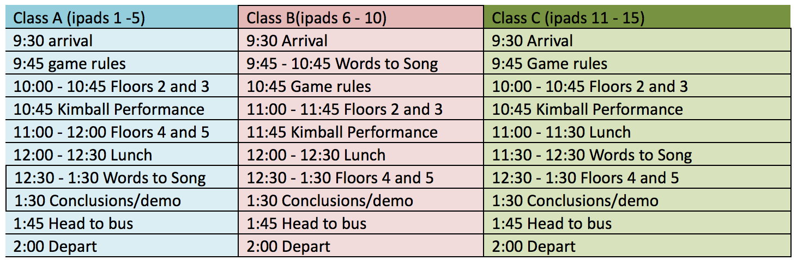
Upon returning to Copperfield School, students will be with their classes reflecting on and connecting our learning from the NMC experience with our current learning at school.

Please contact your child’s teacher should you have any questions or concerns regarding this educational experience.

Regards,

The Grade Four Teaching Team
Mrs. C. Dorish (cydorish@cbe.ab.ca),
Ms. M. Koehler (makoehler@cbe.ab.ca), Ms. A. Miller (acmiller@cbe.ab.ca),
Mrs. K. Ross (kaross@cbe.ab.ca), Ms. M. Young (mayoung@cbe.ab.ca)

